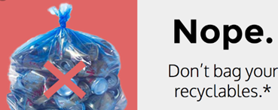  Greene Arc does not accept:  - Glass  - Plastics with any symbol other than 1 or 2   - Plastics without a recycling symbol  - Electronics  - Tires  - Light Bulbs  - Gas or Oil Containers  - Scrap Metal or wire  - Paint  - Batteries  - Waxed milk cartons  - Styrofoam  - Garbage  - Furniture  To recycle these or other items,  call 724-852-5300  or visit https://earth911.com/
  Recycling at
  Greene Arc in
  Greene County, PA
  Greene Arc is the recycling agent for the County of Greene. Our recycling program promotes the independence and employment of individuals with disabilities.
  Drop off recyclables at Greene Arc, Inc.
  197 Dunn Station Rd, Prosperity,
  just west of Ruff Creek store.
  Open Monday through Friday
  8:30 AM to 3:30 PM
  Call first: closed on Holidays and
  some Mondays
  Greene Arc Recycling 724-852-3062
  Greene Arc offices 724-627-5511
  http://greenearc.org/
  Greene County Recycling Coordinator
  724-852-5300
  http://www.co.greene.pa.us
  DO NOT PUT RECYCLABLES IN PLASTIC BAGS! IF YOU BRING YOUR SORTED RECYCLABLES IN PLASTIC BAGS, OPEN THE BAGS, DUMP ITEMS IN CORRECT BIN, THEN TAKE YOUR BAGS HOME. Plastic bags get caught in recycling machines. Recycle them at Giant Eagle or Walmart.
  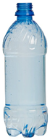
  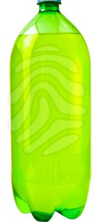
  
  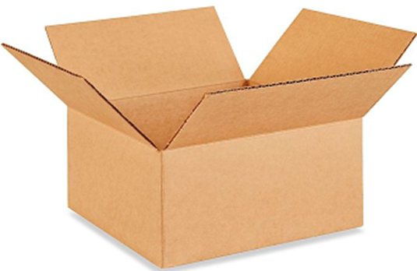
  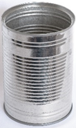
  
  
  Recycling in Greene county, PA
    - Greene County, PA
    - Recycling creates job training for Greene County residents with disabilities.

Items must be sorted.  ONLY the following items go in Greene County recycling:  - Plastic:   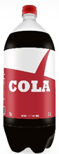      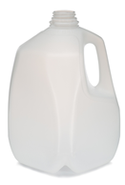  only  - Cans: clean food & drink cans no larger than 1 gallon    - Newspapers/paper/  cardboard  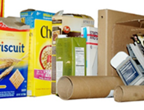   |  |  | DO NOT PUT RECYCLABLES IN PLASTIC BAGS IN THE RECYCLING BINS.  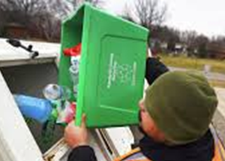  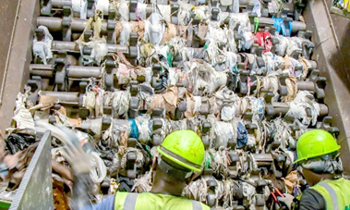  Plastic bags get stuck in recycling machines.  If you bring sorted recyclables in plastic bags, open the bag,  Then just dump recyclables into the appropriate bins!  Consider using cardboard boxes, paper bags, or re-useable plastic totes.  Food/drink cans & plastic must be rinsed clean before putting them into the recycling. |  |  | Drop off recycling at Greene Arc or in these Townships:  Center: 100 Municipal Dr.  Cumberland: 100 Municipal Dr.  Dunkard: (Bobtown-Shannopin  Civic Club, 777 Larimer Ave.)  Jackson: 104 Tunnel Rd.  Monongahela: Mon View Park  Morris: 1317 Browns Creek Rd.  Richhill: Rt. 21, 2 mi. W. of Wind  Ridge on Headley Hollow  Wayne: 123 Spraggs Rd.  Washington Twp.: Greene Arc  Mon-Fri, 8:30 AM-3:30PM  Waynesburg: Franklin St.  between Morgan & East St.,  next to University dorm  parking  Thursdays, 9AM-2 PM  Pick-up services available for businesses by appointment. Call 724-852-3062  Plastics 1 & 2 only,    Giant Eagle and Walmart will recycle your plastic bags  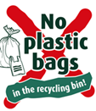  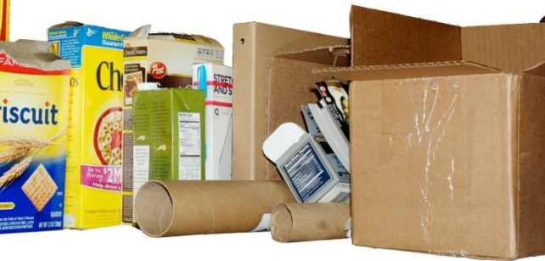  cardboard

